For immediate release: Richard Bangs’ Adventures with Purpose
Richard Bangs’ Adventures with Purpose, a new, one-hour special from American Public Television, will air on _________ (station) _________________ at (time) _______, (day) __________ (date) _________. Hosted by Richard Bangs who is often called “the father of modern adventure travel,” Adventures with Purpose is the pilot episode for a series of adventure travel, eco-conscience, historical documentaries. According to Bangs, “Adventures with Purpose not only quicken the pulse and fire the synapses, they are also journeys of enlightenment and discovery—odysseys that make a difference.”
Adventures with Purpose is produced by Small World Productions, the makers of Smart Travels—Europe and Pacific Rim with Rudy Maxa and Travels in Europe with Rick Steves. The special is co-produced by KCTS/Seattle, and Richard Bangs Productions of Marina del Rey, California.
Sub-titled “Egypt: Quest for the Lord of the Nile,” this episode follows Bangs up the Nile River and deep into the heart of ancient Egypt.
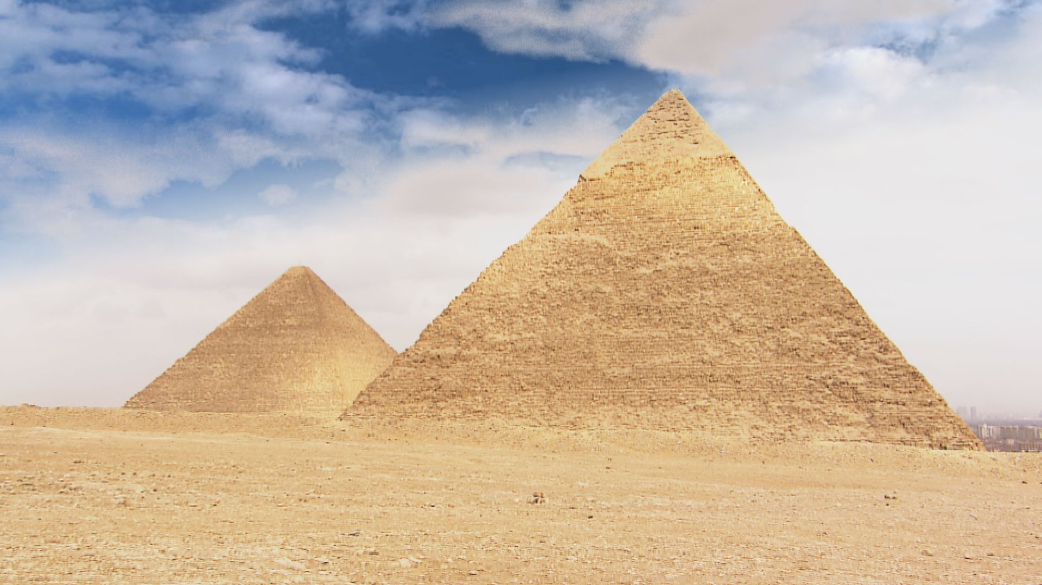
Egypt is a vast desert; a searing sun beating down; inhospitable to man and beast. For millennia only by the grace of the waters of the Nile did people and creatures thrive in this land. Rain almost never fell. But once a year the river magically surged with water, flooding the land and leaving fertile black soil to nourish the crops. And with this annual flood, thousands of crocodiles washed into the lives of the ancient Egyptians. Death by crocodile was common. The scaly beast exacted both fear and awe. The Lord of the Nile made his way into the great tombs of kings and deep into the psyche of the ancients. As time and technology changed, the Lord of the Nile slowly disappeared. Hunting, pollution and the Aswan dam robbed the river of its ancient consort. Today there are reports that crocodiles are making a miraculous return in the south of Egypt. Richard’s goal is to catch a glimpse of this legendary creature in the wild and along the way come to know the powerful god he inspired thousands of years ago.
  Adventures with Purpose | Small World Productions  140 Lakeside, Suite 200, Seattle 98122  206.329.7167  info@travelsmallworld.com  www.AdventuresWithPurpose.TV
This journey is a personal quest for Bangs as well. In the 70’s he led an expedition to explore the upper stretches of many of the great rivers of Africa including the crocodile-populated Nile. This special follows Richard’s new voyage up the Nile and tells the tale of a civilization inextricably bound to the waters of the river and its creatures. From Alexandria to Cairo, from the Great Pyramids at Giza, to the Valley of the Kings, Richard explores the way the Nile and its fearsome Lord molded a society. Further upstream still, Richard visits a temple dedicated to Sobek, the
Press release page two: Richard Bangs’ Adventures with Purpose
Crocodile God, and seeks the beast himself in the waters of Lake Nasser.
Host and co-executive producer, Richard Bangs is a pioneer in travel that makes a difference, travel with a purpose. He has spent 30 years as an explorer and communicator, and along the way led first descents of 35 rivers around the globe, including the Yangtze in China and the Zambezi in Southern Africa. Richard has published more than 1000 magazine articles, 16 books, a score of documentaries and several CD-ROMs; and has lectured at the Smithsonian, the National Geographic Society, the Explorers Club and many other notable venues. He writes a semi-regular feature for the NY Times. His latest book, Adventures with Purpose, published by Menasha Ridge Press, is a companion to this television special. The lead essay in the book parallels the documentary and is a 7500 word article that tells the tale of Richard’s “Quest for the Lord of the Nile.”

DVDs and VHS home videos of Adventures with Purpose: Quest for the Lord of the Nile are available from Small World Productions. Each DVD contains the complete show and more than an hour of value added bonuses: Richard’s adventure travel tales, never-before-seen bonus footage, and behind the scenes glimpses. Richard’s Adventures with Purpose books, DVDs and videos are $24.95 each plus shipping. The book and DVD may be ordered together for $44.95 plus shipping. Viewers may order online at www.AdventuresWithPurpose.TV or call the order desk at 800.866.7425.

Small World Productions, Inc. of Seattle, produces Richard Bangs’ Adventures with Purpose. KCTS/Seattle and Richard Bangs Productions are co-producers. KCTS is the presenting station. Exofficio Travel Apparel provided partial support for production and national distribution of the series. American Public Television (APT) of Boston is the national distributor.

HDTV versions of this special will be up-linked on the public television HD satellite transponder. More than 240 stations will broadcast Adventures with Purpose in high definition format. And more than 250 public TV transmitters are slated to air the NTSC or standard definition, “letterboxed” version of Adventures with Purpose: Egypt. Digital audio is transmitted in stereo.

For 44 years, American Public Television (APT) has been a prime source of programming for the nation’s public television stations. APT distributes more than 10,000 hours of programming including JFK: Breaking the News, Simply Ming, Globe Trekker, Smart Travels—Pacific Rim, Julia and Jacques Cooking at Home, Battlefield Britain, Jungle, America’s Test Kitchen, Lidia’s Italian-American Kitchen and classic movies. APT is known for identifying innovative programs and developing creative distribution techniques for producers. In four decades, it has established a tradition of providing public television stations nationwide with program choices that enable them to strengthen and customize their schedules. The APT press contact is Dawn Anderson at 617-338-4455 ext-149 or via email: dawn_anderson@APTonline.org. For more information about APT’s programs and services visit APTonline.org.
Adventures with Purpose | Small World Productions  140 Lakeside, Suite 200, Seattle 98122  206.329.7167  info@travelsmallworld.com  www.AdventuresWithPurpose.TV
# # #

Contact: John Givens, Small World

